THE POOR MAN’S SPECTROSCOPE

DEVELOPED BY:

DR. JIM ROBERTS
AND
KIMBERLEA DE LA CRUZ
FOR

THE REGIONAL COLLABORATIVE FOR EXCELLENCE IN SCIENCE TEACHING

AT

THE UNIVERSITY OF NORTH TEXAS

SUMMARY PAGE FOR SPECTRA

- Cut a paper shipping box lid (or similar size) in half. (Like the pattern shown in the figures 1 and 2 below.)
- Trim side walls at about 30˚ angle from corner to cut edge.
- Center protractor paper attached to this write up with 180˚ base line 8cm from back wall.
- Mark the center of the back wall.
- Cut a hole at the center point in the back wall, aligned with the 90˚ mark. The hole should be the same diameter as the light “tube.”
- Tape the slit cover over one end of the light tube.
- Insert the tube, slit end first, into the hole, pushing in the tube until is 5cm inside.
- Attach the diffraction slide (on a stand) at the 180º base line of the protractor, 8 cm from the box wall.
- Cut a 5cm white paper strip slightly longer than the outside curve of the protractor. Attach it along the protractor’s curve, standing vertically. It is the projection “screen” for the light tube. See figure 3 to see how this apparatus should look when completed.
- Shine various light sources through the tube and observe the spectral images cast on the paper screen. Figure 4 shows a picture of light from the sun being diffracted by the spectroscope.

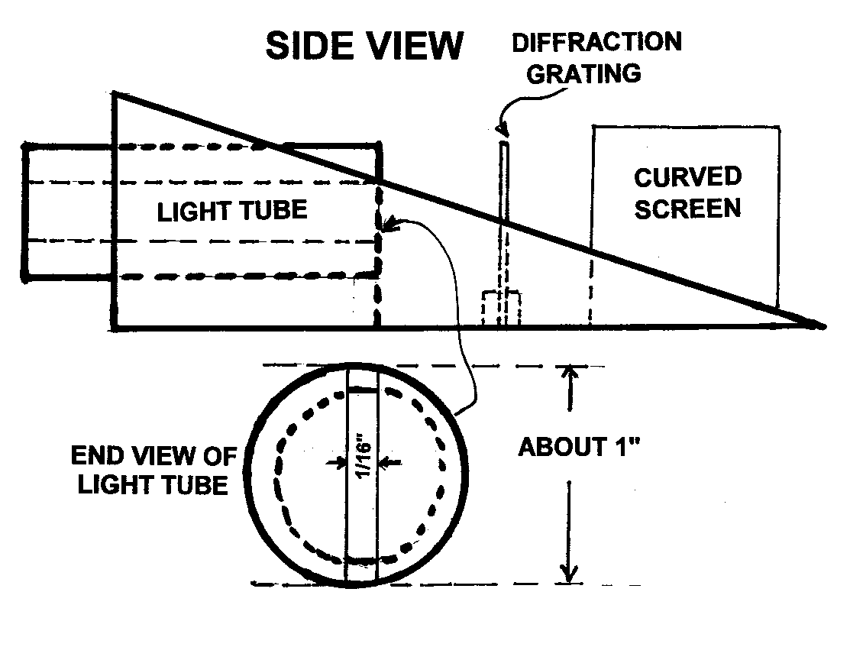
Figure 1. A side view of the poor man’s spectroscope with some dimensions. The dimensions are not very critical.

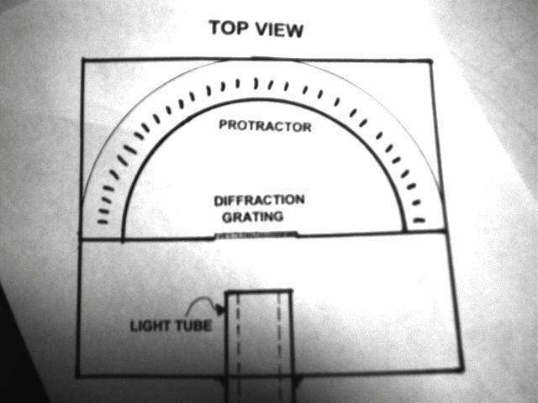

Figure 2. A top view of the poor man’s spectroscope.

Box wall height 11cm Cut length 22cm Width 30cm

PROCEDURE

Familiarize yourself with all of the things on the LIGHT TABLE to learn as much as you can from just looking. Study the hand out sheets on spectra.
You are going to “look into the heart of an atom” and study its spectra by use of a spectrometer.
- Pass a bright beam of light through the spectrometer to make it diffract into colors.
- Measure the angles (both left and right of the center) that each color light beam makes with respect to the central line at 90º and record this value in the table provided.
- Calculate the value of the wave length for each color with the equation:
Λ = d sineθ, where d=1/(600 lines per mm).
The wave length is in mm when you use this equation.
- Tabulate the wave lengths in the table below for a light bulb.

COLOR ANGLE ANGLE Λ(mm) Λ(mm) PERCENT
LEFT RIGHT EXP (BOOK) ERROR

- Tabulate the wave lengths in the table below for a glowing gas.

COLOR ANGLE ANGLE Λ(mm) Λ(mm) PERCENT
LEFT RIGHT EXP (BOOK) ERROR

- Read the angle for the HeNe laser beam and record it in the table below. The small “pocket lasers” or pointers work very well for this activity.

COLOR ANGLE ANGLE Λ(mm) Λ(mm) PERCENT
LEFT RIGHT EXP (BOOK) ERROR

*To compare your results to get % error, find a table of wave length values for each atom or laser and use that value for the “true value”.

If you have any questions about this device, please contact me at roberts@unt.edu and I will be glad to help as I can. Jim Roberts.

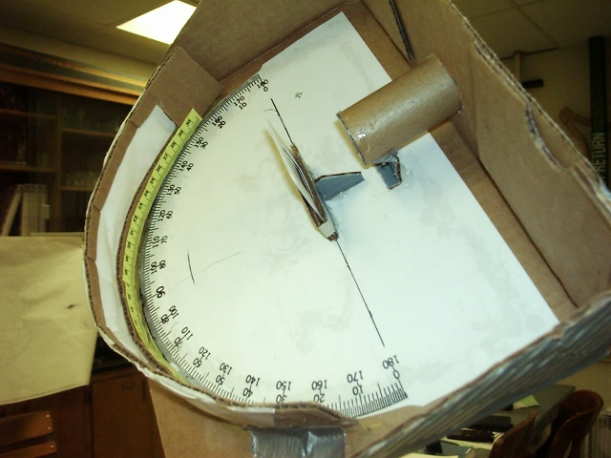

Figure 3. A picture of the completed spectroscope with scale shown.

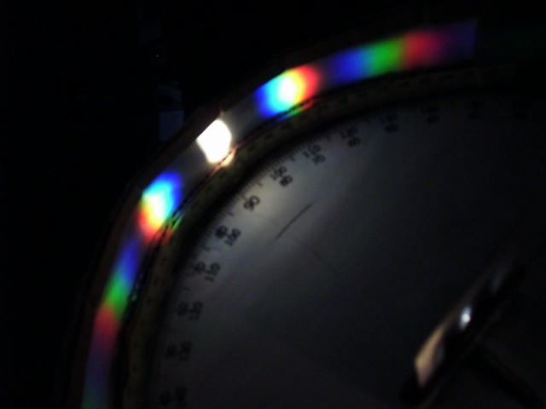

Figure 4. The spectroscope in operation with a spectrum from the sun masked with all but a small beam of light coming into the spectrometer.

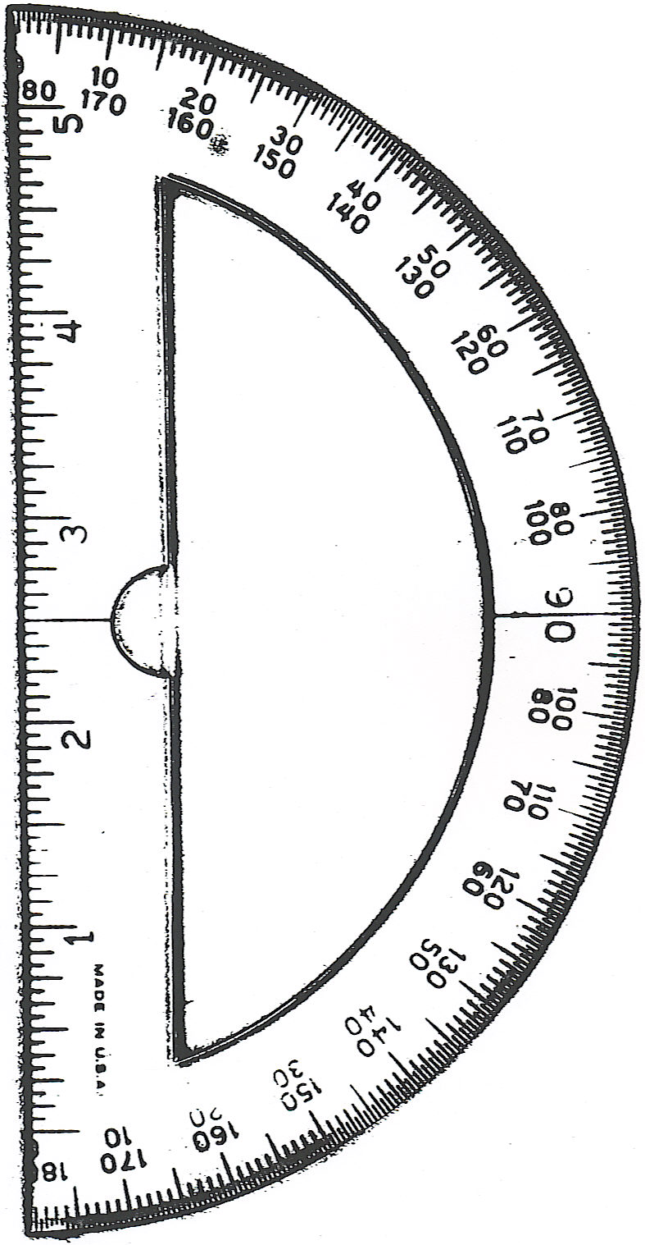
Figure 5. A copy of the protractor to use in the spectroscope.

