CONSTRUCTION AND CALIBRATION OF A THERMOMETER USING THE EA-200 DATA COLLECTOR/ANALYZER AND A TEMPERATURE PROBE
By
Jim Roberts
OBJECTIVES: The purpose of this exercise is to construct a thermometer from simple items, to understand the nature of thermal expansion, to calibrate a thermometer using a Data/Collector analyzer and to display data on a graphing calculator to compare data sets.
INTRODUCTION
A knowledge of the fact that materials, solids, liquids and gases, generally expand when the temperature is raised at a constant pressure condition will enable us to make a temperature measuring device (a thermometer). An exception to this case of simple expansion is that of water, which has some anomalous behavior near 4 degrees centigrade. We will show how water expands and contracts with heat change and choose alcohol to make a simple thermometer.
The change in volume or length of materials can be used as a means of determining the temperature of the material. A long filament or rod of materials will expand or contract when it is subjected to an increase or decrease of temperature. If we have a means of measuring this change, we have a measure of the temperature when the device is calibrated. It is well known that cement highways expand and contract during changing temperature conditions. Expansion joints with tar in them helps compensate for the different length of the joints in summer and winter temperatures.
Since the expansion is usually linear with temperature, a relationship can be written to express the precise nature of the change in length or volume for the material. This relation can be expressed as:
Change in length "proportional to" change in temperature (1)
Or Change in length "α" change in temperature
The symbol α (Greek letter alpha from which we get alphabet, just the first three letters of the Greek alphabet, alpha-bet(a)) is a symbol that means "is proportional to". It saves a lot of writing to use such symbols. In scientific writing, scientists often use such symbols. It is "OK" if the symbol is defined properly for the reader.
By measuring the change in length, we have the change in temperature when an equation is balanced with a constant of proportionality. We get the constant from conducting an experiment over a range of known temperatures. For example, the two temperatures [ice+(pure water)] when in equilibrium (after a long time of waiting) is defined to have a temperature of "zero degrees centigrade" if the pressure is set at one atmosphere. A second temperature [(pure water)+steam] is defined to have a temperature of "100 degrees centigrade" when the pressure is at one atmosphere. Since the expansion is linear, we need only these two points and we can divide the scale into as many divisions as we like. One scale is divided into 100 divisions from which the term "centigrade" comes, literally one hundred (centi) divisions (graduations).
Another thermometer scale that is in popular usage is the Fahrenheit scale. This scale has a different number of divisions from that of the centigrade. It is not generally used today in scientific applications. There are, again, two reference points needed to establish the range of the scale. A mixture of ice water, salt and ice causes the ice to melt at a temperature of zero degrees Fahrenheit. This temperature becomes zero on the Fahrenheit scale. The upper scale is defined as above for the centigrade scale by boiling water. However, the temperature is not 100 degrees centigrade but 212 degrees Fahrenheit. This causes some confusion for the two scales. The value of 100 degrees centigrade is the same point as 212 degrees Fahrenheit. The two scales, however, do not have the same lower temperature, but 32 degrees Fahrenheit is the same as 0 degrees centigrade. This comparison is seen in figure 1.
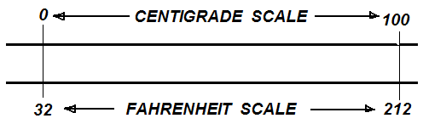
Figure 1. Comparison scales for the centigrade and the Fahrenheit scales with two reference points marked on them.

The two scales were adopted for usage in the various countries over which the French and British had their influences. The choice of scales is determined by politics rather than scientific principles. Either scale is accurate, if calibrated, and one does not have merit over the other, although some refer to the centigrade scale as the scientific scale. The scientific method can be employed in the usage of either.
One of the earliest attempts to make a thermometer was by Galileo. He used a trapped amount of air in a container to move a liquid in a U-tube to measure the change of Volume of the air as the temperature of the apparatus took place. The thermometer worked but had a limitation in that the atmospheric pressure caused the readings to vary too. The basic apparatus is shown in figure 2. It is a very simple and ingenious device for its time. It had to await the development of the gas laws by Robert Boyle to be fully understood as a temperature and pressure device. Out of this thermometer grew the Barometer of Evangelista Toricelli, which is used to measure the pressure of the atmosphere at constant temperature. One invention in science often leads to another one.
Note that the apparatus is quite simple in design and can track temperature effects on the gas (air) trapped inside the sphere. Generally, expansion of the gas phase of a substance is much greater than the solid or liquid phase under the same pressure conditions.
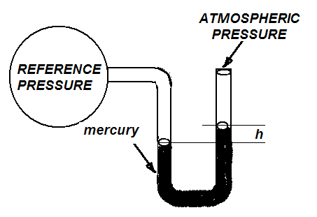
Figure 2. A sketch of Galileo's thermometer apparatus. The height h is a measure of the pressure difference in the tube. This u-tube is sometimes referred to as a “U-tube manometer”.
A knowledge of the expansion properties of a solid, liquid or gas may be used to make a thermometer from any one of these materials, if we understand the basic concepts involved. In figure 3 can be seen an example of how the volume expansion with temperature increase can be used to make a thermometer. The small tube of transparent material allows the volume change in it to be used to measure the temperature change on the larger volume sphere. The two volume changes must be equal or the apparatus will break or be distorted. Recall what happens to a coke in a bottle or a glass of water when put in the freezer compartment of your refrigerator and allowed to freeze. The water expands more than the glass and breaks the container. This difference of amounts of expansion is referred to as differential volume expansion. This just means that there is different amount of change in one of the materials as compared to the other.
The length of the liquid shown in figure 3 changes by a larger amount than the tube that holds it. This difference allows the liquid to move along the tube in an amount proportional to the temperature. The equations that give the volume expansions are given by the volumes of the sphere and the cylinder. The volume of the cylinder is
Base area times the height = πhr²_{cylinder} (2)
and the volume of the sphere is given by:
Volume of a sphere = 4/3(πr³_{sphere}) (3)
The volume changes are then found by changing the values of each r and h to the new values. Recall that each length changes according to equation (1). Some understanding of the mathematics is needed, but it can be seen that taking differences for the volumes and equating them for the cylinder part and the sphere part of the apparatus will give the needed equation to determine the temperature for the thermometer. You don't need to understand the equations to make the thermometer and calibrate it. The next part of the exercise consists of making the thermometer with a bottle and a clear soda straw. Figure 4 shows how this construction is made.
In order to make the thermometer, take a drink bottle of about one fourth pint capacity and clean it of any drink remaining. Make a small hole in the cap of the bottle through which an ordinary soda straw can be put. Carefully seal the area around the straw and the lid so that no liquid can escape from the bottle. When this procedure is complete, fill the water to level capacity and put the lid and straw in place with the bottle in the upright position. Check the water level in the bottle to make sure that it is at the top of the container and no air is trapped in the bottle. Add a small amount of water to the straw to make the level of water about two centimeters above the cap of the bottle. Your thermometer is now ready to be calibrated.
Recall that there are two temperatures that are well known and which define the upper and lower limits of the two main thermometer scales, the centigrade and the Fahrenheit. Place your thermometer in a bath of ice and water and wait until the water level in the straw stops falling. Mark this position with a felt tip pen or a permanent marker and record the value on the attached cm scale. Next, put the bottle in a pan of boiling water and watch the water in the straw rise. When the level of the water in the straw stops rising, your thermometer has come to the temperature of the boiling water, 100 degrees centigrade. Make a mark at this position. Your thermometer now has two points on it for the beginning and end of the scale. If you want more points, you can obtain them by dividing the thermometer interval into as many division, as you like. Since the scale is linear, you can make a mark in the middle of the two points. This will provide three points. Check the linearity of the expansion of water by calibrating a number of points against a standard probe. This is done in the following way by using the temperature probe and an EA-200 Data Collector/Analyzer.
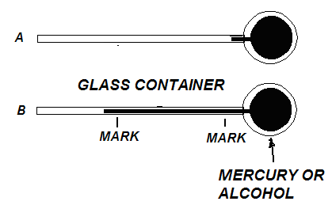
Figure 3. A sketch of the two volume changes, that of a cylinder and that of a sphere, used to make a thermometer. The volume of the bulb expansion must equal the volume of the expansion in the cylindrical portion of the device. Since the glass has a much lower coefficient of expansion than the mercury or alcohol, the height of the filament in the cylinder will change significantly with change in temperature. The sensitivity of the thermometer can be adjusted this way.

Assume that the EA-200 and its temperature probe are highly accurate after calibrating them against the two standard temperatures, water and ice (0) and steam and water equilibrium (100). Conduct the following exercise to find the intervening temperatures. Set up the EA-200 to take a set of data points as you change the temperature on a container of water that has the constructed thermometer and the temperature probe in it. Cycle the water from zero degrees, water and ice, until the temperature has increased to about 100 degrees C. As each data point enters the data collector record the height of the liquid in the straw with a short metric ruler. The set up is shown in figure 5. The calibration data for the thermometer is given in Table 1. Three measurements are made, that from the EA-200, that from the laboratory thermometer and that from the constructed thermometer. You can now use the thermometer to make measurements of temperature around you.
When you have finished construction of your thermometer, use it to make some measurements and to answer the questions given below.
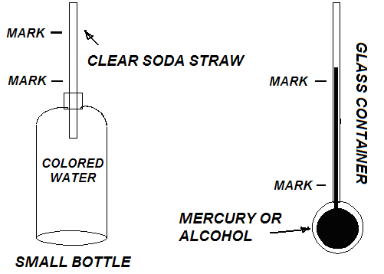
Figure 4. A diagram of a thermometer made by using a soda straw, water and a drink bottle. The sensitivity of the device is determined by the radius of the straw and the size if the bottle used for the reservoir.

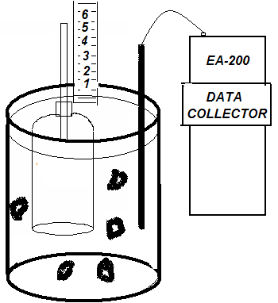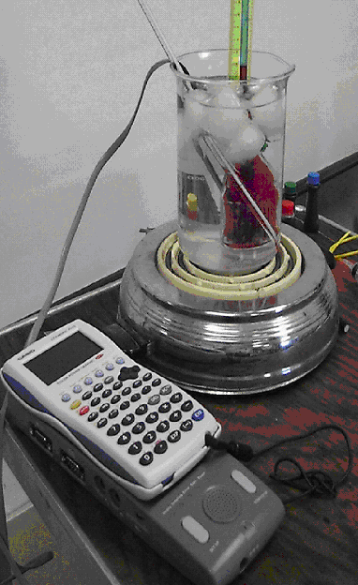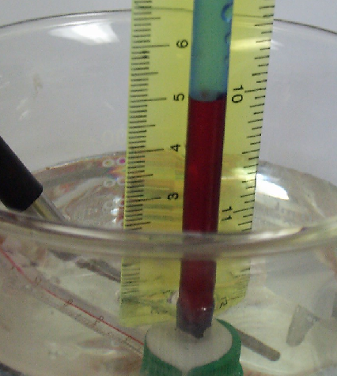

Figure 5. (Left) A schematic of the container of water and ice to cool the temperature to near zero degrees C for calibrating the thermometer. (Center) A picture of the complete set up for conducting the calibration experiment. (Right) A close up view of the thermometer. The EA-200 and probe serve to standardize the measurements and the level of the liquid in the straw is a measure of the temperature in the bottle. Pictures taken using the Casio QV-7000SX digital camera.

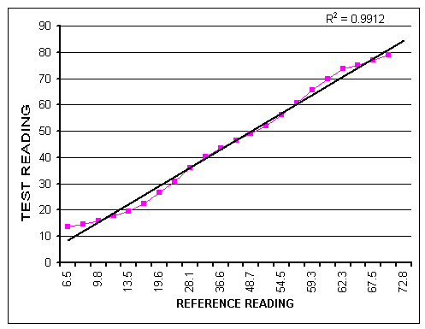Figure 6. Calibration curves for comparison of the data for the test thermometer and the standard reference probe thermometer. Analysis of the data is made using the CFX 9850GC Plus graphing calculator. The equation for the true temperature is given by {1.12T(L)+7.2} with L the length of the column of water. This equation depends on the ratio of the straw radius to the volume of the bottle chosen for the liquid reservoir. {T(L) = 13.1L(cm)-8}.
QUESTIONS
1. Can you think of a temperature that is well known that may serve as another data point? Think! Do you have fever today?

2. If you can obtain a thermometer from a store or from the school supply, compare several readings with your thermometer.

3. Since water freezes at zero degrees, can this thermometer that you have made be used below freezing?

4. Since water turns to steam at 100 degrees centigrade, can your thermometer be used above that temperature?

5. Think of how you can modify (change) your thermometer to increase its range.

6. Can you think of a way to use a strip of metal to make a thermometer?

7. Would wood be a good material to consider for a thermometer?

8. Is glass a good material to make expand or contract to make a thermometer?

9. The resistance of carbon changes linearly with temperature. How can we use carbon to make a thermometer?

- Some transistors are sensitive to temperature change. Do you think we can use a transistor to make a thermometer?
- Temperature of the human body is taken with a special thermometer. Traditionally, mercury thermometers were used due to the highly linear property of the expansion of mercury with heat. Why are these types of thermometers no longer in general use?

ADDENDUM
Water is not the best liquid to use in constructing a thermometer. It has anomalous expansion near 4 deg C and is not linear over the entire range of temperatures 0 to 100 C. Much work has been done on the properties of water and it is suggested that some of this material be used to help teach the scientific method and how to make the best choice of materials to make a thermometer.

