Inverse r²-Square Law Behavior
By
Jim Roberts, Professor of Physics and Material Science
University of North Texas

OBJECTIVE: This set of activities is designed to show that a number of physical laws are expressed by an “inverse square law” or as 1/r² using data collectors and graphing calculators.

Introduction

The concept of an inverse-square (1/r²) relationship had its beginning with Newton’s law of universal gravitation concerning falling bodies in the gravitational field of the earth. He expressed his law, using some of the experimental results of Galileo as follows:

F_{g} = {Gm₁m₂/r³}(r) (1)

Sometimes written as

mg = {Gm₁m₂/r³}(r) (2)

Where m₁ and m₂ are the masses of the two bodies interacting, G is a universal constant and r is a unit vector along the line drawn between the centers of the two bodies. This can best be shown by a sketch as follows:

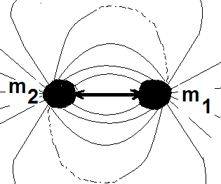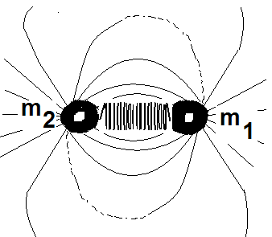
Figure 1. (Left) Two masses separated by a distance r. (Right) The pull of gravity may be treated as a spring connecting the two masses and with a force constant k.

We can think of a spring connecting the two bodies together and the spring causes the interaction. The true picture is more difficult to understand in that it requires that we understand “action at a distance” in which there are no connections between the two bodies that are interacting with each other. This is a difficult concept and we explain it by the use of a “field” that surrounds the two bodies. This field then connects the two bodies by use of a simple test Mass that examines the presence of the field. Briefly, we can see how this works by use of a sketch. We imagine that lines of force go out radially in all directions from a point at the center of the body providing the force. The field lines reach to infinity getting weaker and weaker as we move away from the body. One thing to know is that we have observed a gravitational field that “pulls” on every other mass. We do not have gravity that “pushes”; it always pulls. Such a gravity that pushes bodies away is referred to as anti-gravity. The masses m₁and m₂ will always be pulled toward each other, so we draw an arrow pointing toward each mass to show only attraction. There is no “negative gravity” in our known universe.

The concept of a field can be extended to apply to light and the rest of the electromagnetic spectrum.

INTERACTION BETWEEN CHARGES

Consider two charges and the law of interaction between them.

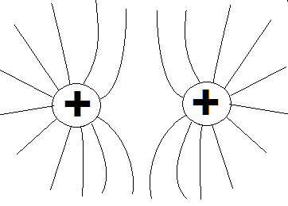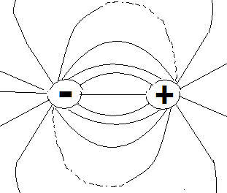
Like charges repel Unlike charges attract

Figure 2. Symbolic representations of like charges and unlike charges with field lines surrounding them.

The general rule is that “like charges repel” and “unlike charges attract”. This qualitative rule can be made specific by the Coulomb law of the form.

F_{g} = {KQ₁Q₂/r³}(r) (2)

This “looks like” Newton’s law with the masses m₁ and m₂ replaced by charges Q₁ and Q₂. Note that the form is an “inverse r-square law”.

This law can be explored using light, gravity, sound, electrical charge and magnets. The procedure to do this is the objective of this set of activities.

MATERIALS
1. Light source
2. Meter stick to measure
3. Small cylinder about one half meter in length
4. Light probe
5. EA 200 Data Collector Analyzer to collect data
6. Graphing calculator to view data display

PROCEDURE

Set up the apparatus as shown in figure 3. The distance from the light source can be measured by moving the meter stick along in one cm increments for 20-25 points of distance. This will give an adequate set of data to show the trend in the curve for the intensity of light versus distance from the source. When all of the data have been collected by the EA-200, it is transferred into the graphing calculator using the standard procedure in the operations manual for the two devices.

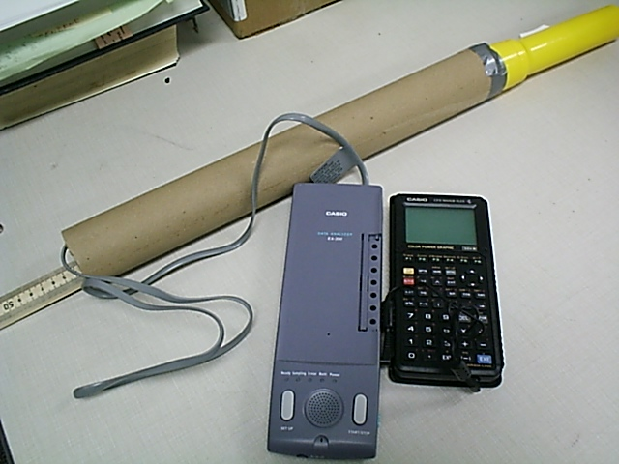

Figure 3. A set-up to measure light intensity as a function of distance from the source. A light tube is used to shield the probe from stray light. The meter stick is moved in one cm increments away from the light to obtain distance versus intensity data. A simple two-cell flashlight (yellow object) is used for the light source.

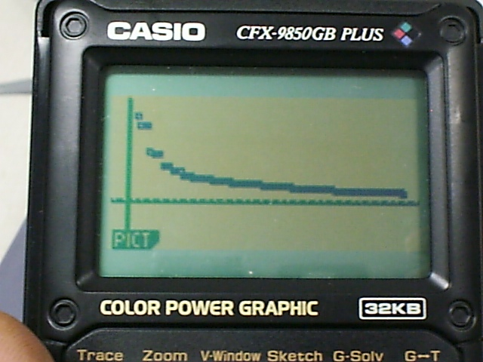

Figure 4. A graphic display of the intensity of light versus distance of the probe from the light source. The curve falls off as 1/r². The data are shown in Excel plot on the right of the picture.

When the data for light intensity has been gathered and plotted, the apparatus is set up to test the behavior of sound as a function of distance from the source. The set-up is modified to include a sound source to replace the flashlight and a microphone to replace the light probe. The signal intensity is measured in the same way with the distance changed in increments of one cm and the sound level recorded in the EA-200 in the same way as for light.

A small loudspeaker is put in place of the flashlight and is driven by an oscillator. The sound generator may be in the audible range or outside the range of the human ear. It is suggested that the frequency is chosen in the audio range and at a pleasing wavelength so that the experiment will not be irritable during the gathering of data. The result of one experiment is shown in figure 5. It has a similar pattern to that for light and one can conclude that sound follows an inverse square law.

Figure 5. A plot of sound amplitude versus distance from the source. The nature of the curve is an inverse r²-square behavior. The pink dot curve represents the inverse r²-square behavior. The blue dots are the experimental numbers obtained by using the sound source and a microphone to collect data with the EA-200 Data Collector.

The apparatus to test the behavior of sound versus distance is the same as that in figure 2 with the flashlight replaced with a speaker driven by a sound generator and the light probe is replaced with a microphone. The data are gathered in increments of one cm units as the meter stick is used to move the microwave along in the tube. The tube serves to eliminate stray sound that may mix with the sound wave generator signal.

Questions

- Cite some sources that may show an inverse r²-square law behavior.

- How can we test the properties of two charges to determine if the inverse r²-square law behavior holds?

- Can you set up an experiment that will enable us to test the interaction between two magnets to test for an inverse r²-square law behavior?

